**by this date. *Any application emailed after July,15, 2023 will be considered ineligible*.**

**emailed to:**

**emailed to secoed2013@gmail.com**

**EMAILED**

**August 15, 2023**

**August 1, 2023**

**July 15, 2023**

2023

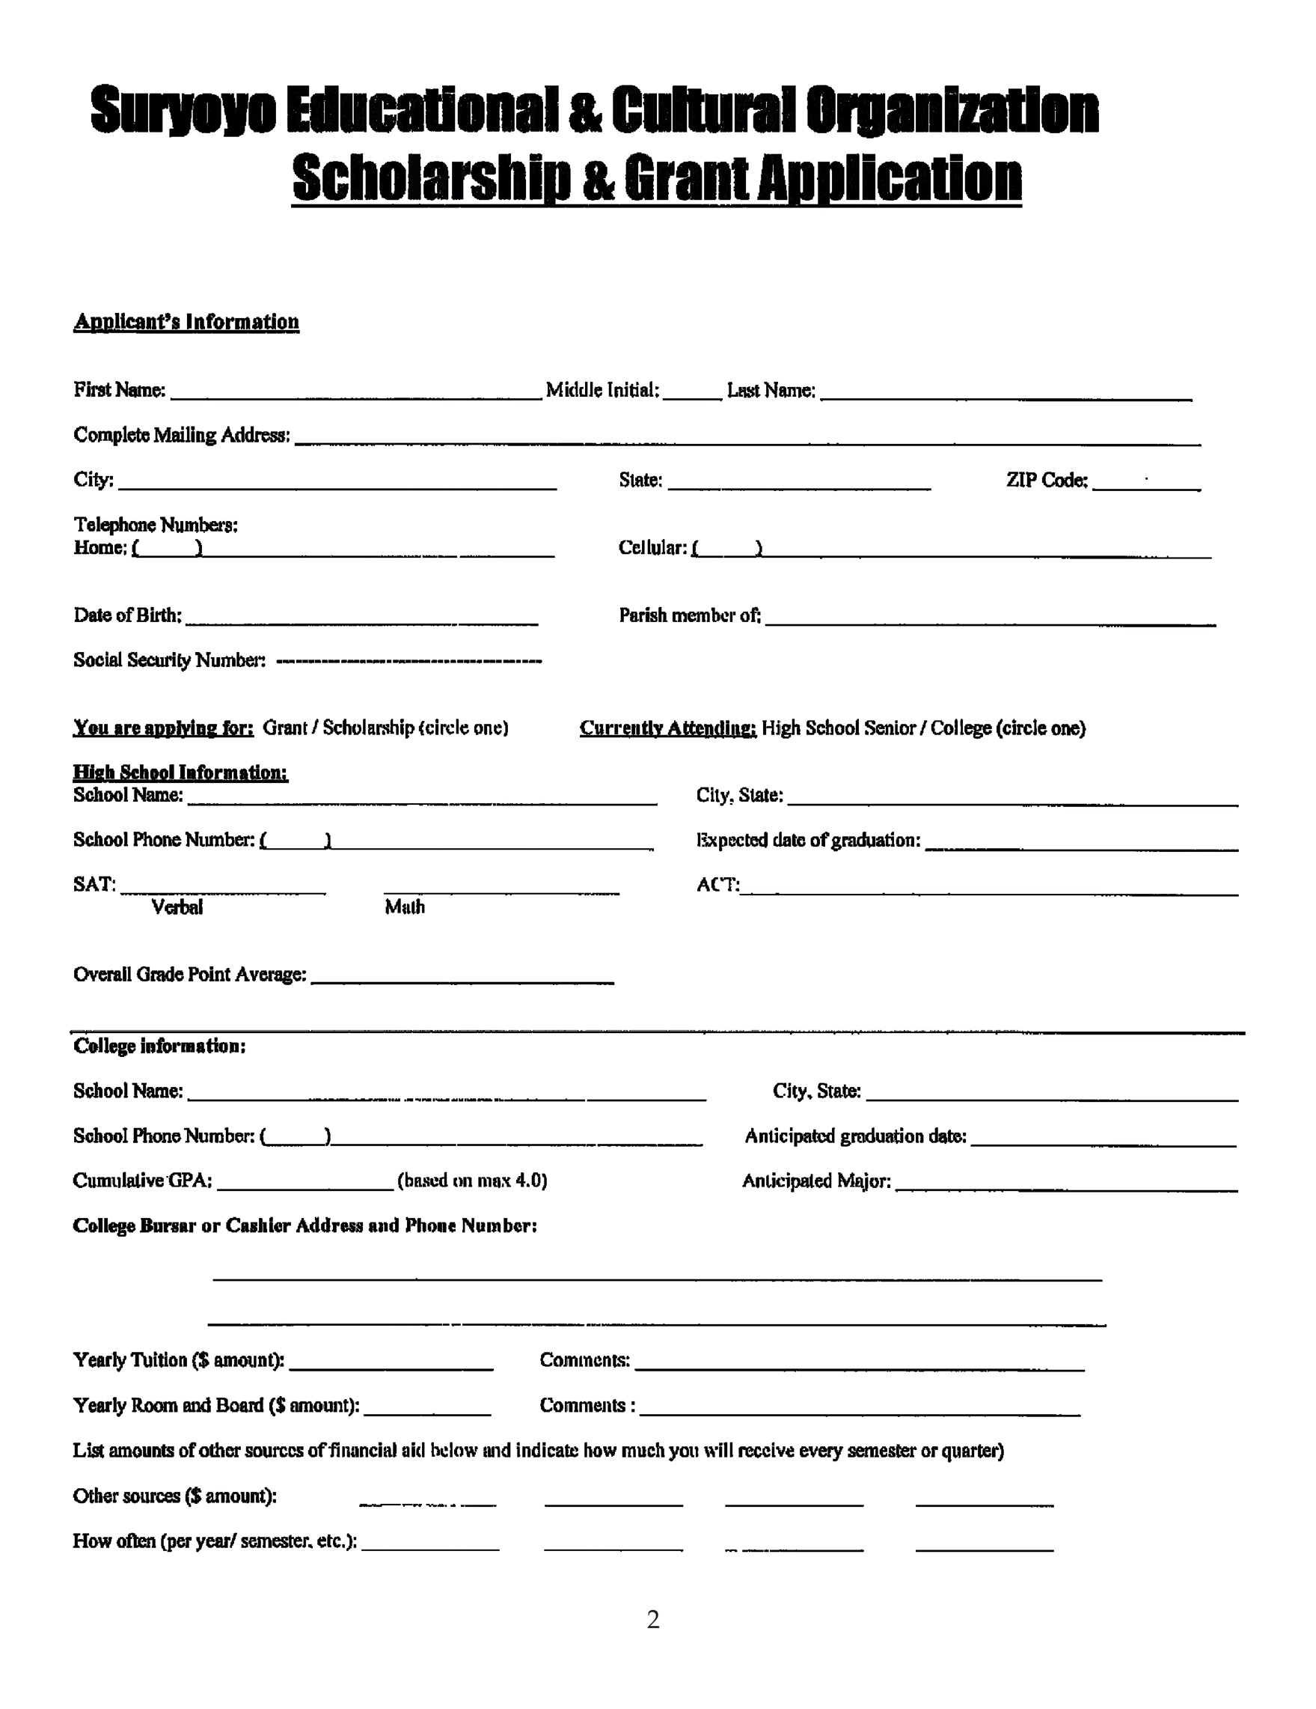

**\*Email Required:** ___________________________________________

2023

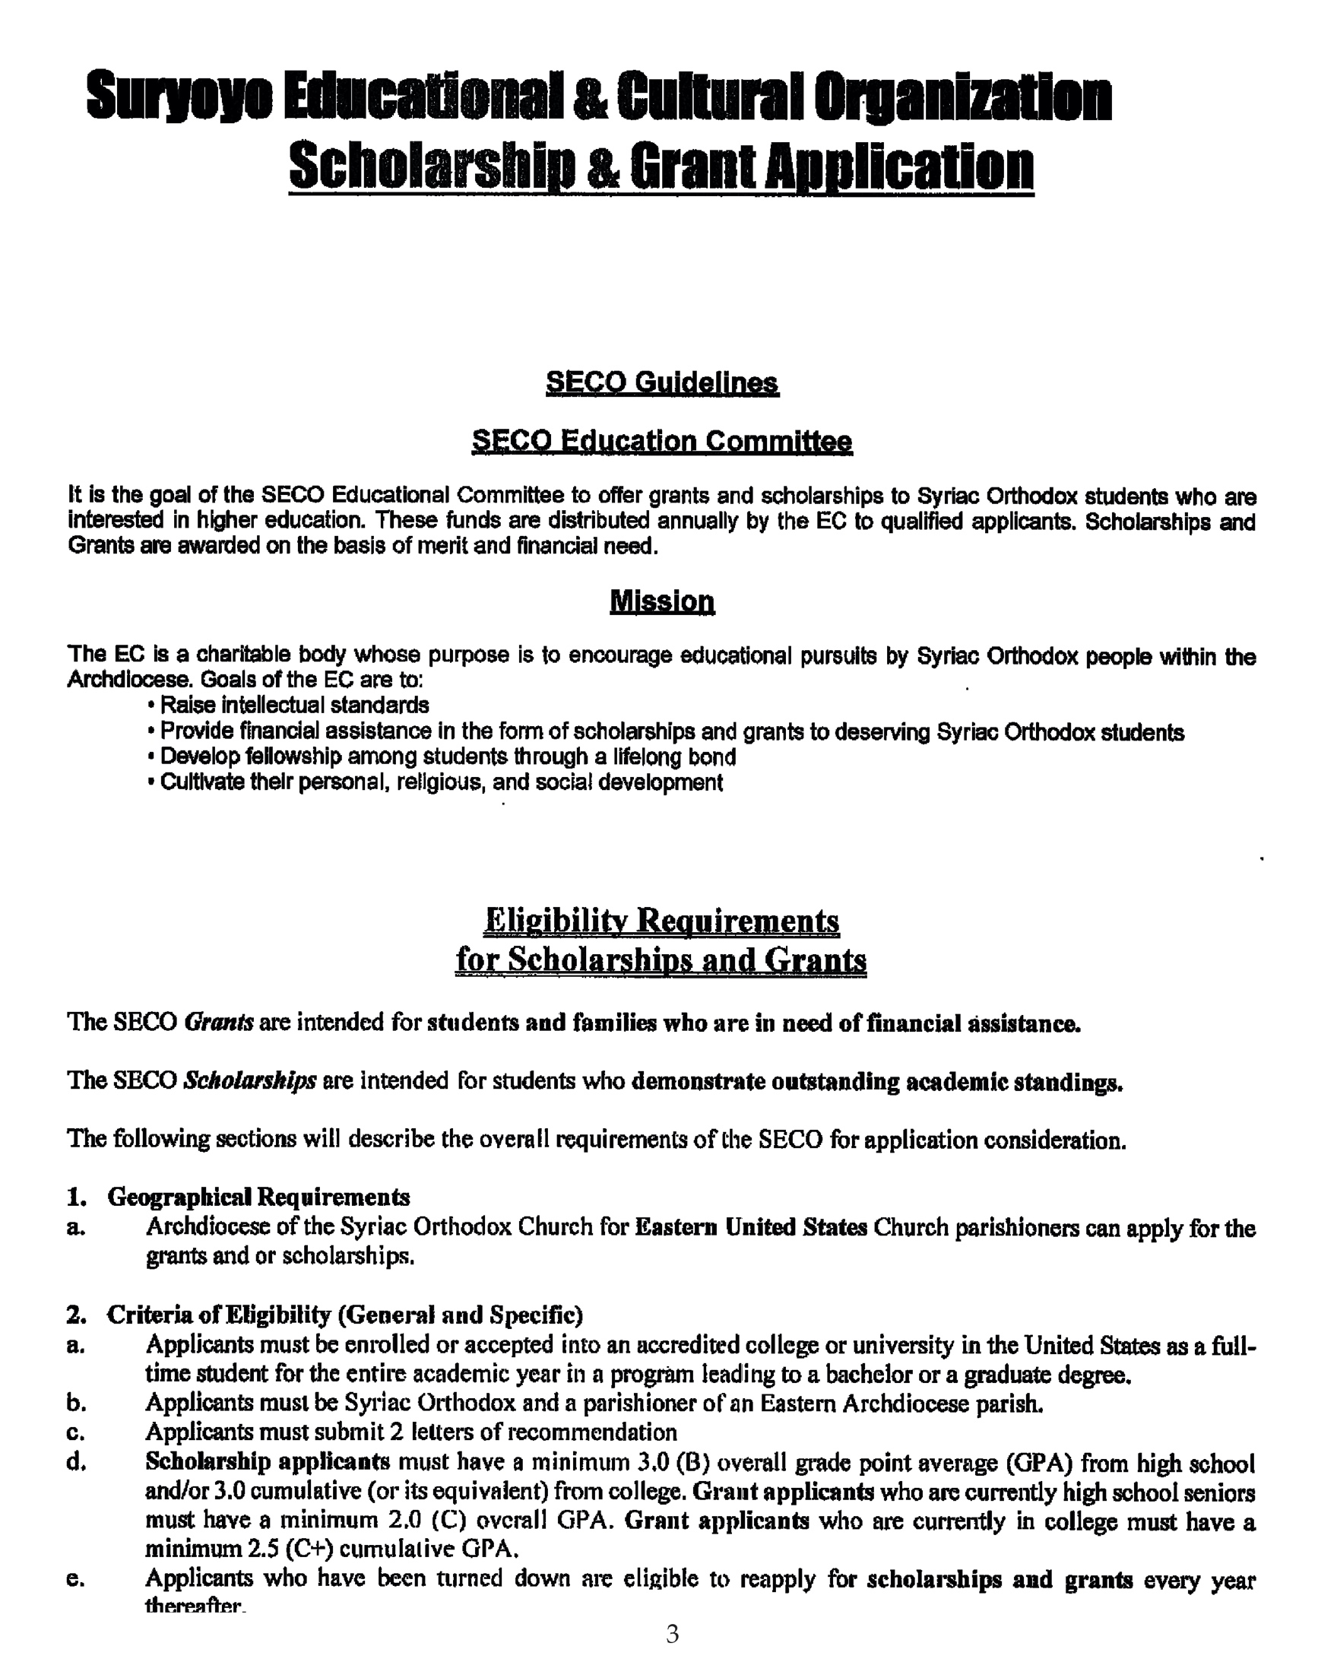

2023

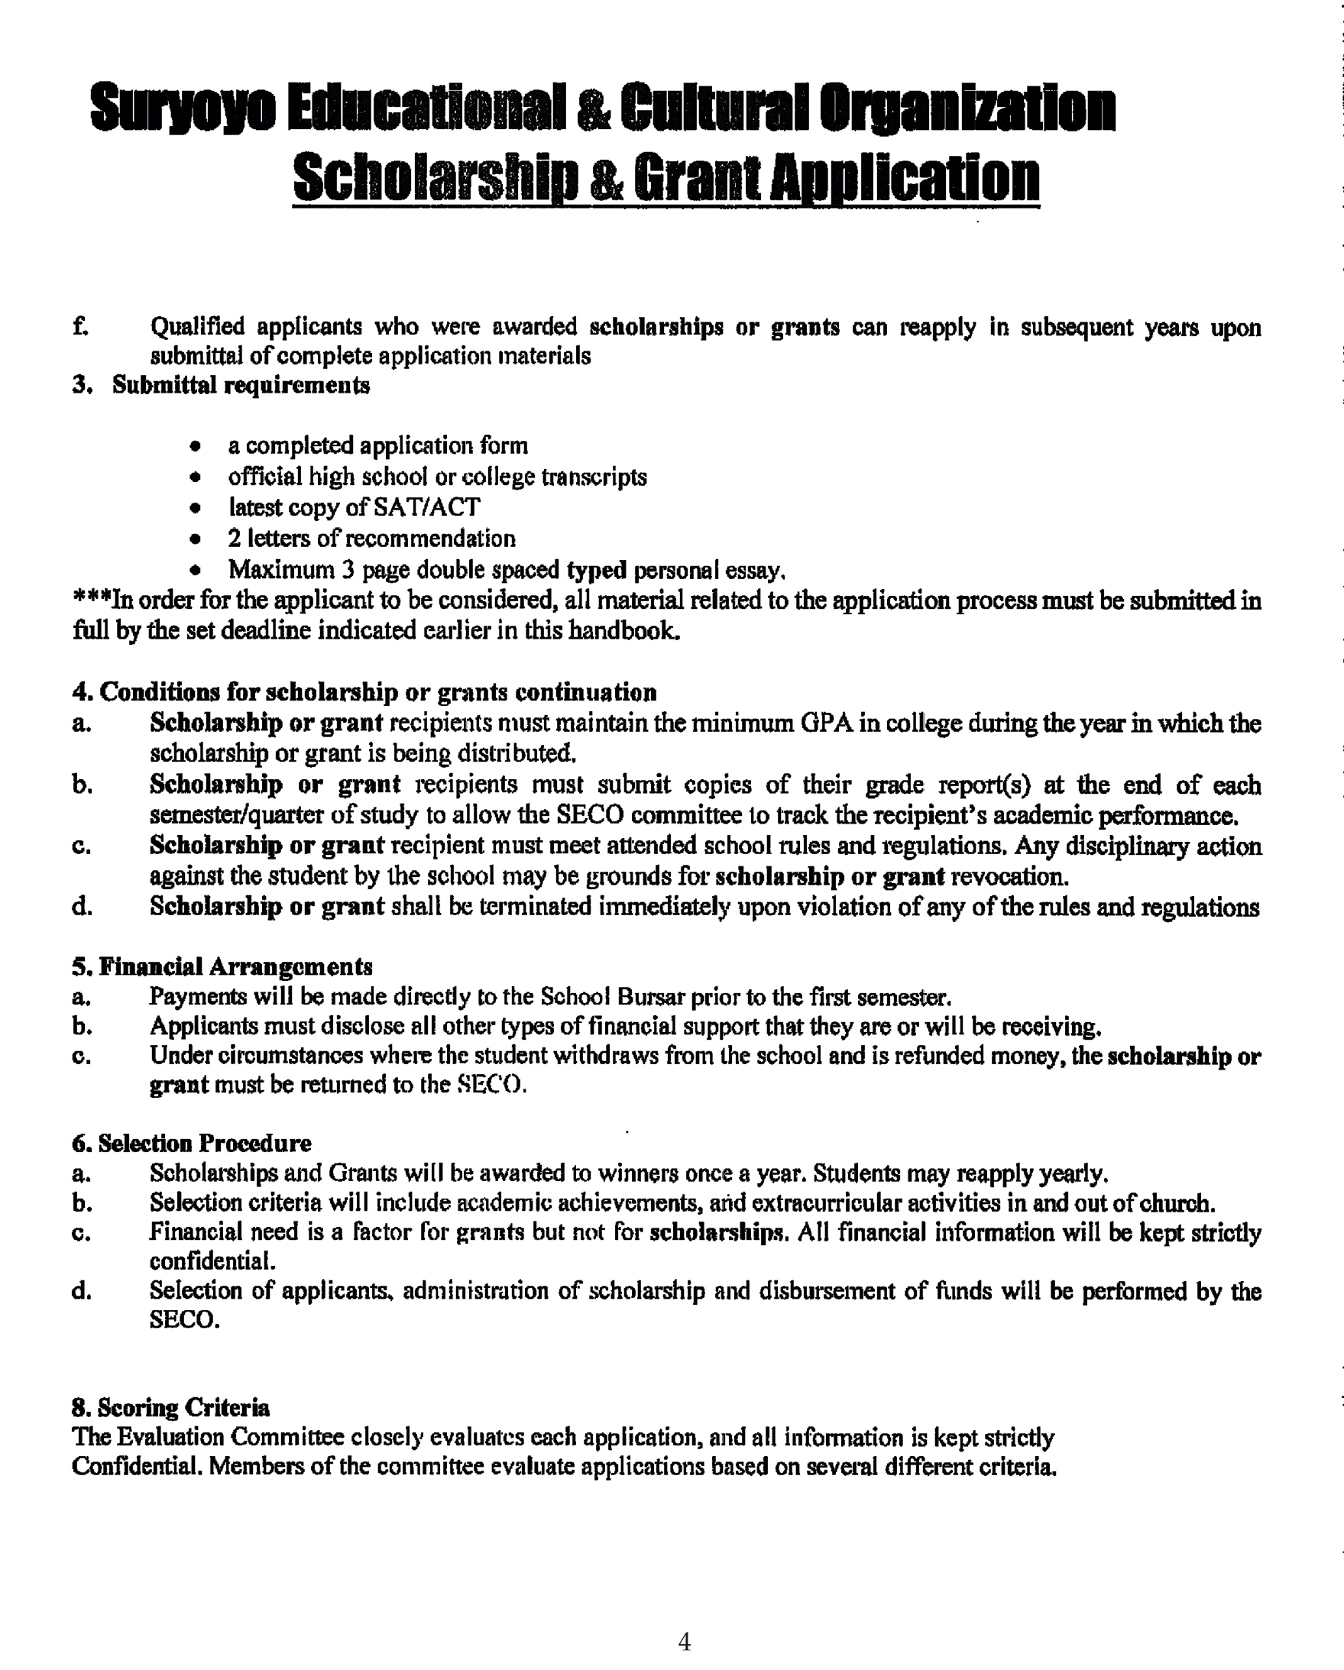

2023

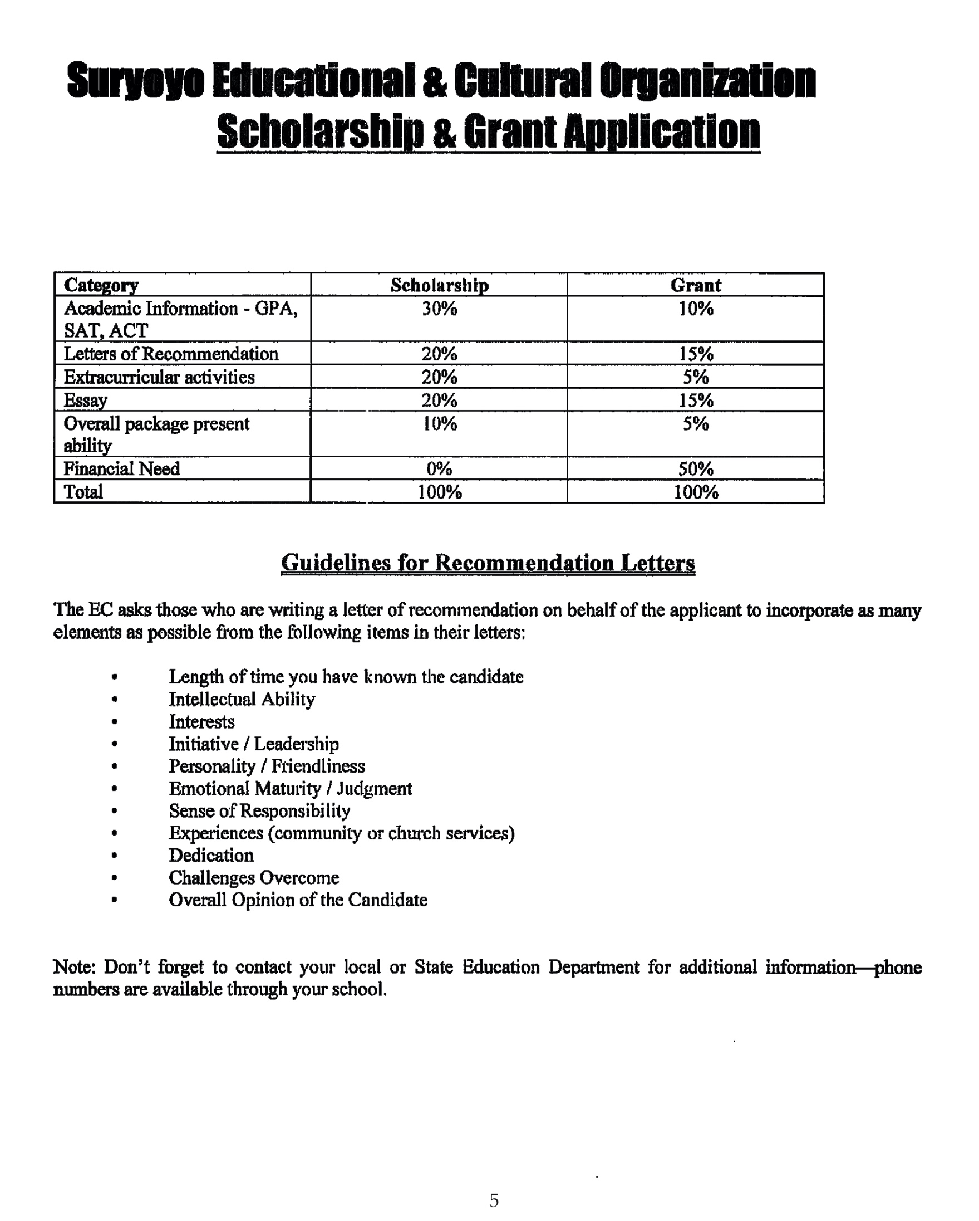

2023